Proposed implementation of first classes for Sprint 1

The Board:
After rethinking how the players move around the board, it became more obvious that moving around to set points around the board made the most sense. The board needs to have properties on it, these properties have an order, starting at Go and then circling back around. Each of these properties need to be their own objects as they need to have a method that checks whether that property is available to buy or rent needs to be paid etc.
Therefore, it is beneficial if the board is a container of these properties, holding them in an ordered data structure that represent the direction the players go around.
Additionally, the board could work as a great Game Manager class, holding the “Bank” (holding all the available money and the action cards) and dictating who’s turn it is.
In Summary, the board needs:
- A data structure to hold properties
- A field and methods to distribute money
- Methods to start and end a players turn when needed

What Data structure?
I think the most practical data structure is the linked list for 2 main reasons.
- Player movement: The simplest and most efficient player ‘movement’ is to give the player a pointer that just points to the property it is currently on, then the ‘movement’ is just updating that point by going to the next item in the linked list

- Easy to make circular: An array would work as the data structure; however, a linked list can very easily be circular by just having the terminal node point to the start node. This solves the issue of having to check when the end of the array is reached and then starting from the beginning

Below is an example of what a very small could look like in terms of structure
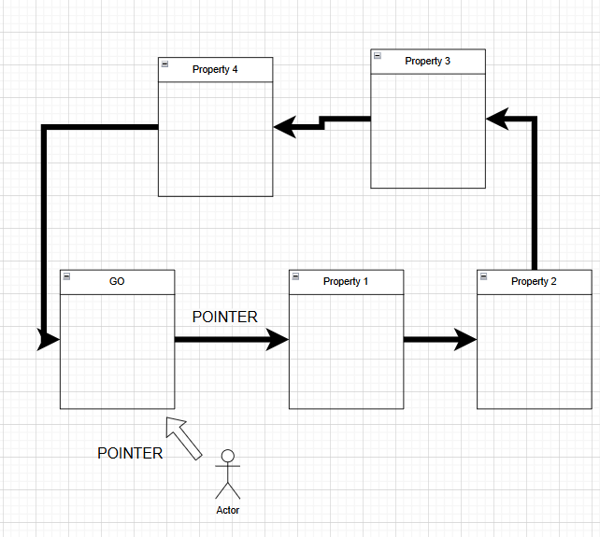

Implementing the Board:
This section will briefly mention some of the necessary fields and methods needed for the board
  - Fields:
- Private Integer: Money
- Private String: Current player’s turn
- Private Linked List: Properties
  - Methods:
- Void NextTurn() : starts the next players turn

- Void GiveMoney(GameObject.Player Player): gives money to the inputted player

- Void TakeMoney(GameObject.Player Player): takes money from inputted player

- Integer Balance(): Returns the amount of money in the bank

- Void GiveCard(GameObject.Player Player): Gives the player a random special card

The Player:
For now, I will not go into too much detail, but my idea of making the player “move” is by updating the player’s pointer by the number rolled on the dice e.g. rolling a 3 will update the pointer to the next property node, 3 times. Below is an example of what this could look like
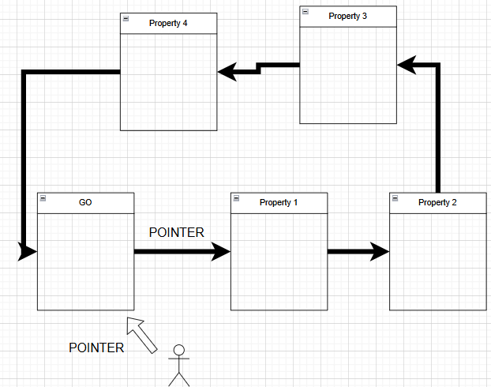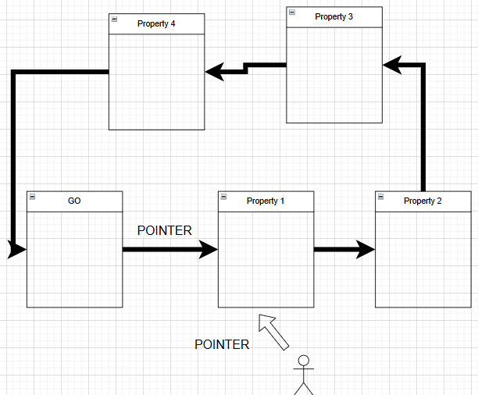
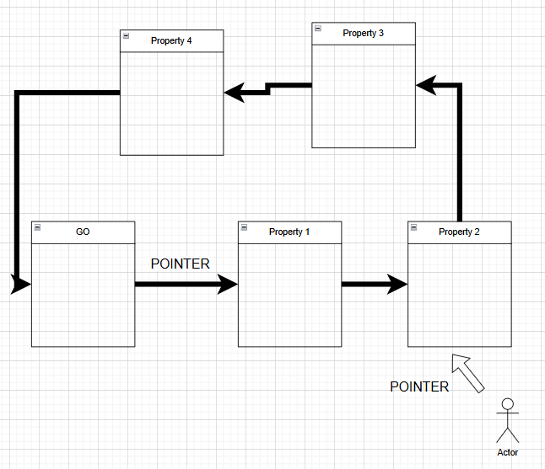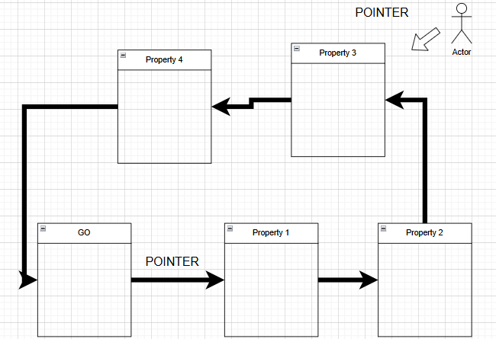

Implementation of Player:
There are quite a few key fields and methods for the player, unsurprisingly, this is most likely to be the largest and most complex class
  - Fields
- Private Integer Money
- Private Enum Token_Name: (it is an Enum as there is only a set of about 5 names the token can have)
- Private Array Owned_Properties
- Private GameObject.Tile Current_position (initialised at Go tile)
- Private Integer Jail_cards
- Private Boolean In_Jail
  - Methods
- Void Move(): Firstly, it should update the Tile it is on so that the player no longer appears on it (removing it from the array of players). Then it finds the next tile in the linked list and then updates Current_position to that new node. It should then call the Pass() method at the new tile so that the player can be displayed

- Void DiceMove(Integer Dice_Value): This simply calls the Move() function the amount of times given by the value rolled by the dice, my thought would be to add a wait() in between each call of Move, so that it looks like the player moves along each space until it hits its destination, as opposed to it teleporting straight there. Also, this method should have a local variable called Final_Destination , so that an additional method is called at the property tile if it is its final destination(for more explanation, check the Implementation of Tiles section)

- Integer RollDice(): A player presses a button to roll a random integer function between 1 and 6 twice, then adds them together and returns the sum of them.

- Array HeldProperties(): Returns an array showing what properties are owned

- Void EndTurn(): The player can press a button to end their turn, can only happen after they roll.

- Integer UpdateMoney(Integer Amount): Increases or decreases the players money, usually in response to buying/auctioning property, or from the special cards (e.g. Pay dental fees! Lose $50)

- Void BuyProperty(): If the property the player is on can be purchased, the player can press a button to buy the property, this should then call the UpdateMoney() method, subtracting the cost of the money. Additionally, it should change a field on the property object itself, so it is clear that it is owned by a player.

For now, this should give some core functionality and would be a great place to stop for this sprint, there is lots of additional functionality needed like selling properties, trading etc. but not needed for plenty of time. Additionally, it is important later on to create subclasses, one for a human player, and another for an AI.

Tile Class:
The Tile class should consist of one main superclass, then a couple of subclasses for the different kinds of tiles, such as properties, card pick-up tiles, Jail, Go, Free Parking. The aspect that ties all these subclasses together is that the player can land on these tiles, so the superclass helps to reduce some repetitive code.
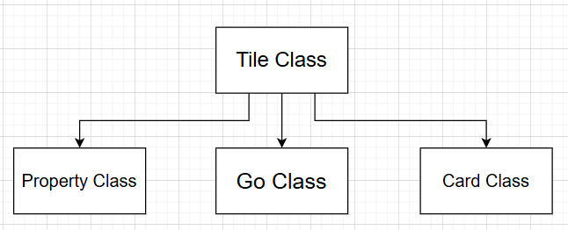

Some Classes for Now:
For this sprint and the next, the main focus should be having a Go tile (so that there is a clear starting location), Property tile and card tile so that we can use the spreadsheets to input the data into the cards.
  - Main Features of each class
Property Class
- Purchasable
- Contains 2 subclasses, Estate and Station_Util, an Estate can have houses and has a standard rent system that doubles when a set of colours is reached, Station_Util has a unique rent system (e.g. utilities roll a number on the dice and pay x amount based on it) and cannot have a house placed on top. For now, these subclasses do not need to be implemented
- Has rent price that scales with property of the same colour
- Able to be sold
- Belongs to a set based on its colours (e.g. blue properties, red properties)

Go Class
- Starting point for each player
- Gives players £200 when passed (not only if landed on)
Card Class
- Gives players a random card
- Two different pools of card, ‘Opportunity Knocks’ and ‘Pot Luck’
- Can move players or give/take money, can affect all players, not just the player that picks up the card

Reading the Spreadsheet:
This is a very important aspect, but for this sprint, it is not essential. For now, simply focusing on having these classes is better and then letting the next sprint focusing on getting this data to function.

Displaying the Player:
The player needs to be shown on whatever tile it is currently pointing to. This will be done by running a method that checks an array containing the names of all the players currently on the tile. This method will then grab those names and display the appropriate sprite for the tokens. An example can be seen below
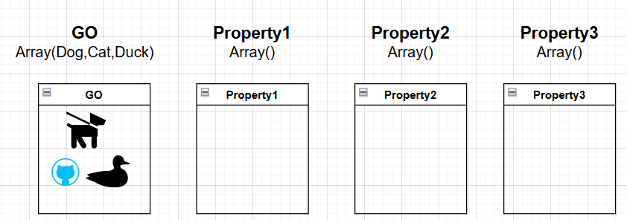

The Dog Player Rolls a 2:
The Property1 Tile would run the Pass method, as the Dog has not reached its final destination, it will then run the Exit() method as the player moves to the next tile
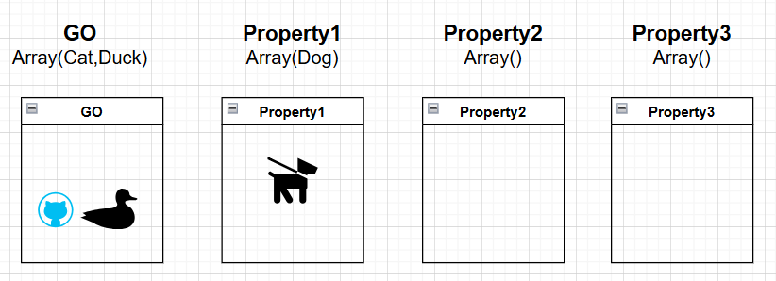
The Property2 Tile would run both the Pass and Check method, as the Dog has reached its final destination, it will not run the Exit method yet, as it has to wait till next turn to move again
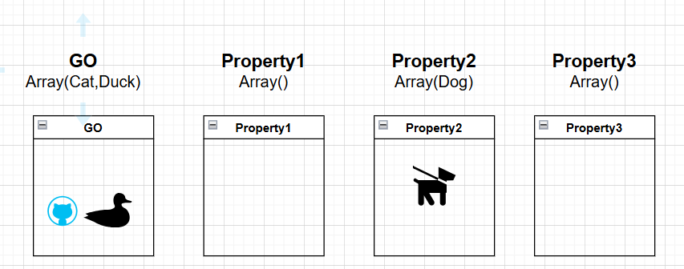

Implementation of Tiles:
This will be very minimal as this is only describing the superclass, with all the aspect that are shared among the subclasses.
  - Fields
- Private Array Players_Here
- Private String Description
  - Methods
- (Overridable) Void Check(GameObject.Player Player): Activates the cards effect on the player e.g. initiates the prompt to purchase property, gives a card to player. This should be overridden by all subclasses, as they have different effects. Notably, this should NOT activate if the player simply passes the tile, only if the player stops moving there, this will be known if the players Final_Destination variable matches the name of the current card.
- Overridable Void Pass(GameObject.Player Player): This should be run every time (even if it is the final destination), it will update the tile’s sprite so that it includes the new player and adds the player to the Players_Here list. It is overridable as the GO space will also give the player money for simply passing it.

Wrap-Up:
I hope this gives some useful clarity on a way we can implement some of the fundamental aspect of the games. This is a rough guide, nothing needs to be done the way it is, many thing will probably be changed, but this was the most comprehensive me and Evie could think of.

Signed –
Alex as Primary Writer
Evie as Logistics and Diagrams Assistance

